

**INTERNSHIP REPORT**

BACHELOR OF SCIENCE

In

Data Science and Analytics

By

**I.Sneha**

C3S48861

Under the Supervision of

**Dr. G. Preetha**

**Duration : 18th June to 27th June, 2024**



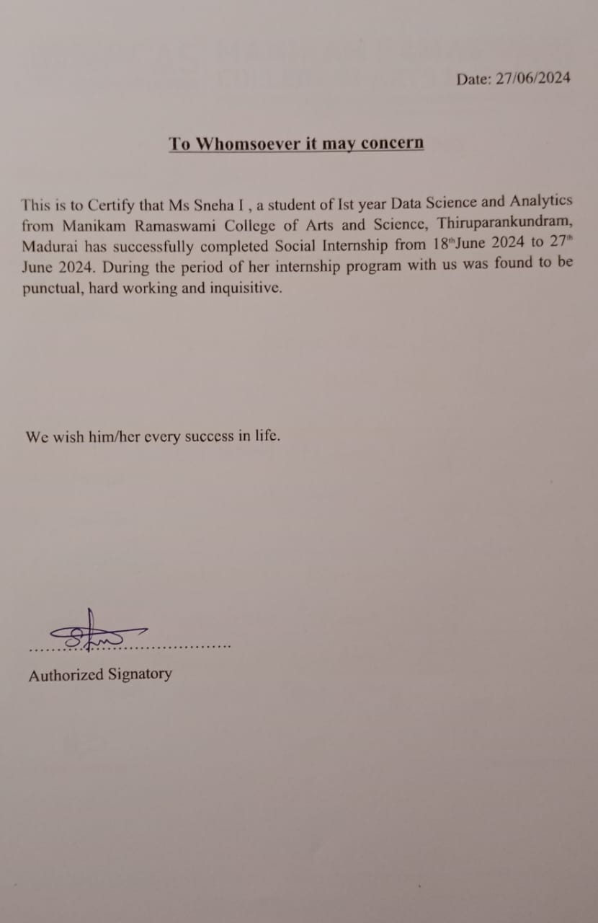

**CERTIFICATION**

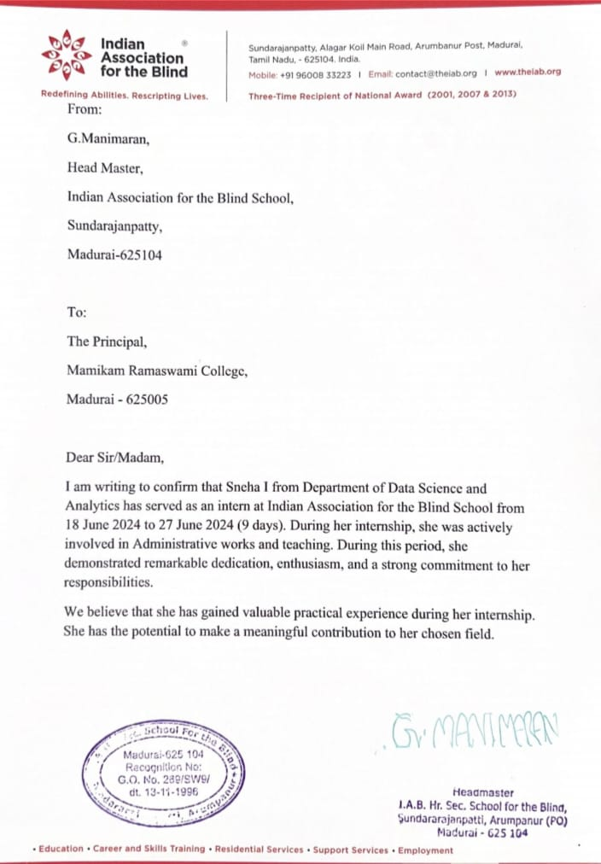

**ACKNOWLEDGEMENT**

First I would like to thank the **Head Master of Indian Association for the Blind School**, Madurai for giving me the opportunity to do an internship within the organization.

I also would like all the people that worked along with me in **IAB Higher Secondary School** for the Blind, Madurai with their patience and openness they created an responsible working environment.

It is indeed with a great sense of pleasure and immense sense of gratitude that I acknowledge the help of these individuals.

I am highly indebted to **MS. Lavanya**, IAB for the facilities and guidance provided to accomplish this internship.

I would like to thank my Head of the Department **Dr. G. Preetha** for her constructive support throughout my internship.

I am thankful to **Manikam Ramaswami College of Arts and Science** for providing me with the opportunity to undertake this internship as a part of my academic curriculum.

I am extremely great full to my department staff members and friends who helped me in successful completion of this internship**.**

**ABSTRACT**

This report presents a comprehensive analysis of my internship experience at Indian Association for the Blind School, a leading school in the visually challenged students. The primary focus of the internship was to understand and analyze the impact of various digital activities and strategies on student database and administrating the school functions. Through a hands-on approach, I was involved in the planning, execution, and evaluation of digital campaigns across multiple platforms, including social media, email, Spread sheet preparation, and student database accountability using leading software.

The internship provided an invaluable opportunity to apply theoretical and practical knowledge acquired in academic studies to real-world scenarios.

The internship underscored the importance of adaptability, accountability, teamwork, and continuous learning within the fast-paced digital technology.

This report details the projects undertaken, skills developed, and lessons learned throughout the internship, providing a holistic view of the profound impact social awareness and survival of the society around us.

Overall , the experience has significantly contributed to my social activities.

**INDEX**

|  |  |  |
| --- | --- | --- |
| **Si.No** | **Contents** | **Page** |
| 1 | Organization profile | 1 |
| 2 | Introduction | 2 |
| 3 | Functional aspects of the organization | 3 |
| 4 | Day wise detailed activities by the student  4.1 Day 1  4.2 Day 2 | 4 |
|  | 4.3 Day 3  4.4 Day 4  4.5 Day 5 | 5 |
|  | 4.6 Day 6  4.7 Day 7 | 6 |
| 5 | Conclusion | 7 |
| 6 | References | 7 |

1. **ORGANIZATION PROFILE**

Indian association for Blind founded in 1985, Madurai, steadfastly supports visually impaired individuals through diverse programs and initiatives. These include educational support, vocational training, advocacy for accessibility, and community integration efforts. The organization’s commitment aims to enhance the quality of life and empower the visually impaired community in Madurai and beyond.

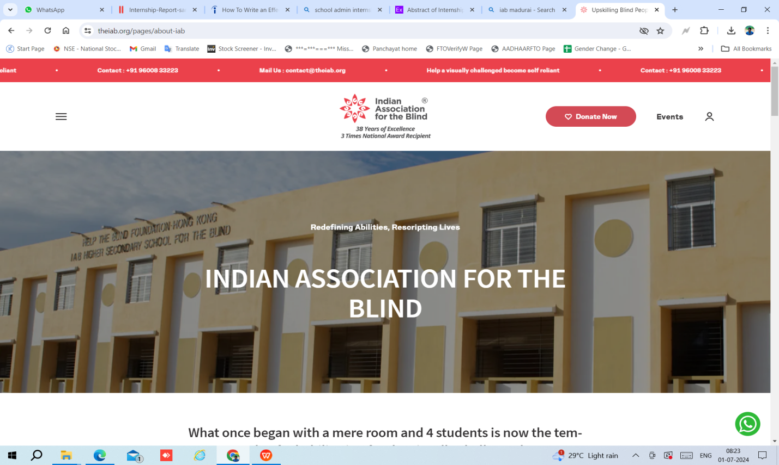

**Awards & Recognition**

* Millennium Award
* CSR Award
* IBN7 Super Idol Award
* National Award
* Award for Eminence
* National Award for Best Role Model
* State Award
* Guruvar Award

1. **Introduction**

Nestled in the village of Sundarajanpatti in the outer fringes of Madurai in Tamilnadu, the Indian Association for the Blind (IAB) promises the visually challenged a life of confidence and opportunities. Started in 1985 by S.M.A. Jinnah, a visually challenged activist, IAB has been the pioneer in empowering the visually challenged towards self-reliance through various initiatives.

The story of IAB stemmed out from the inspirational life of SMA Jinnah. Despite losing his vision at the age of 13, and much against the wishes of his family, Jinnah chased a dream called education. His passion for education saw him pass out of school and later college with a brilliant performance. The key to empowering people with visual disability that would help them travel the road to independence and self-reliance, Jinnah realized, was education.

He established the Indian Association for the Blind (IAB), on January 14, 1985, with the support of well wishers. IAB began with just eight students. In the early years, it served as a tuition/guidance centre that also provided hostel facilities for four visually challenged boys.

Having undergone numerous struggles to complete his education, Jinnah envisioned a changed future for thousands of visually challenged children by providing them education. This dream led to establishing IAB, the institute that has made remarkable progress, be it in the number of lives it has touched or numerous services that are being offered. Currently, in Tamil Nadu, out of the 30,000+ educated and vocationally trained visually challenged people, 20% are being educated, rehabilitated, and even employed by IAB.

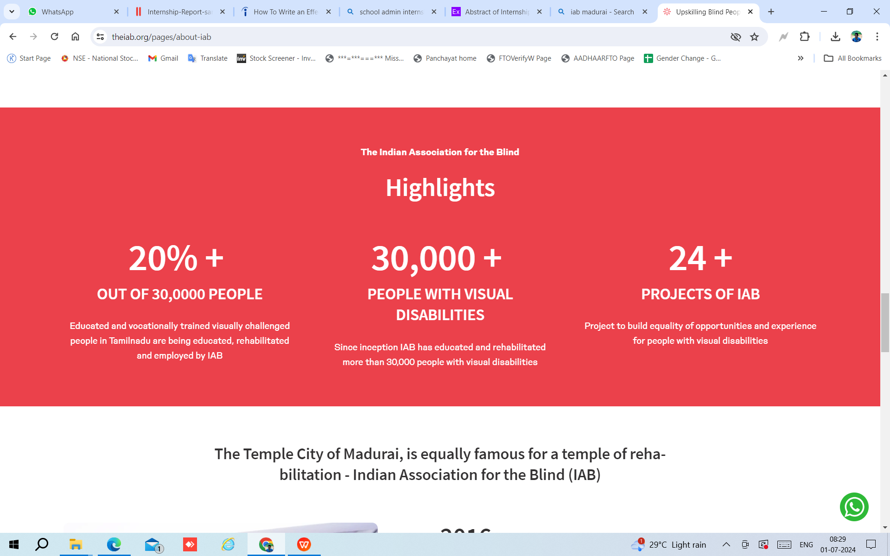

1. **FUNCTIONAL ASPECTS OF THE ORGANIZATION**

The IAB Social Intern will Contribute to Our organizations mission of promoting Community engagement. This internship offers an opportunity to gain hands on experience in social Policy research.

While making a meaningful impact in our community. Our group was divided and each member had a Specific task to complete. And administrative officers Supported us very much. We learned teamwork and time management.

The Internship was Supervised by Ms. Lavanya and we received guidance from her. The intern is assigned for 9 days 18/6/2024 to 27/6/2024. Each day we learned many things like how to work on google sheets and excel. We also learned some life lessons from the Visually challenged Students.

IAB to provide appropriate education, intervention, training and advocacy which will lead to awareness, empowerment and employment of people with disabilities with the help and support of trained Staff and Caregivers and to take measures for prevention, Cure and mitigation of disabling Conditions. IAB School provides medicines for the students. And provides hostel and foods for the Students. In totally 54 Students in that school. The school may have VI to XII Standards. Every day evening IAB conduct yoga for the Students

Through More than 24 initiatives,

The Indian Association for the Blind (IAB) has educated and trained more than 30,000 visually challenged people which forms 20% of visually challenged people in the State of TamilNadu.

**Donor History:**

Give India

Global Giving

Synechron

CAF America

Nestle India

1. **DAY WISE ACTIVITIES:**

**4.1 DAY 1**

On Day 1 of my internship at Indian Association for Blind, Madurai, I worked on administrative postal work. This stamping and pasting addresses onto the post covers. I completed around 500 postal items.

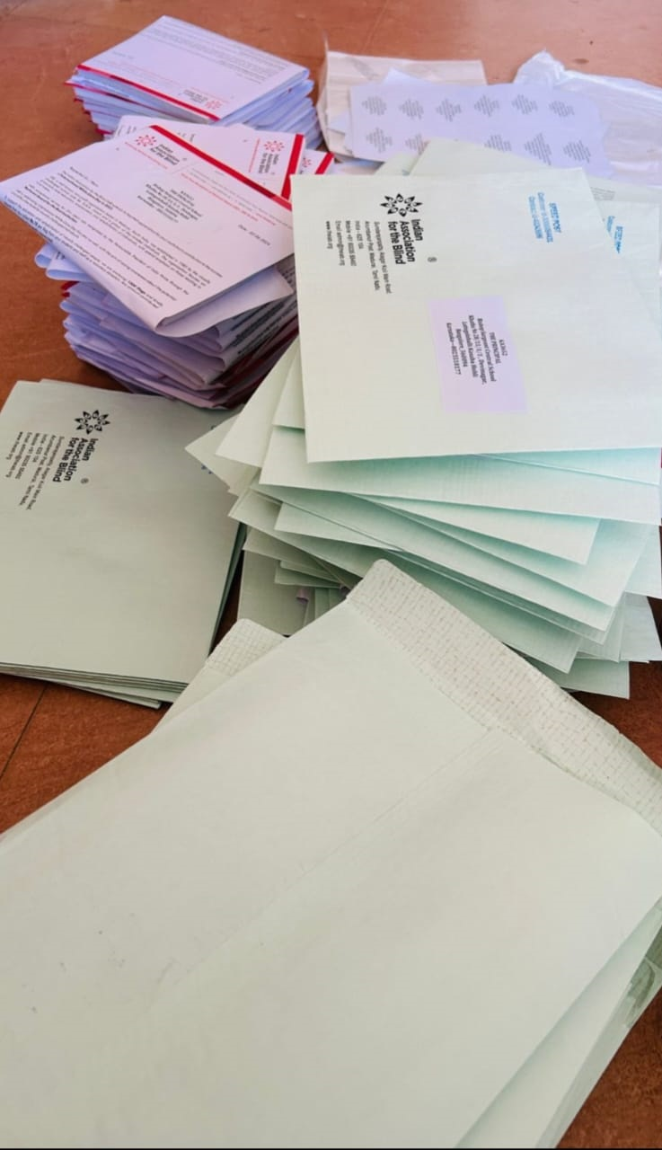

**4.2 DAY 2**

On Day 2 of my internship at Indian Association for Blind, Madurai, I worked on data entry tasks. I collected the Students details. And I entered students EMIS numbers and Aadhar numbers into Excel sheet.

**4.3 DAY 3**

On Day 3 of my internship at Indian Association for Blind, Madurai, I personally collected comprehensive information from students. This included details about their students biodata, family backgrounds, necessary for completing scholarship forms.

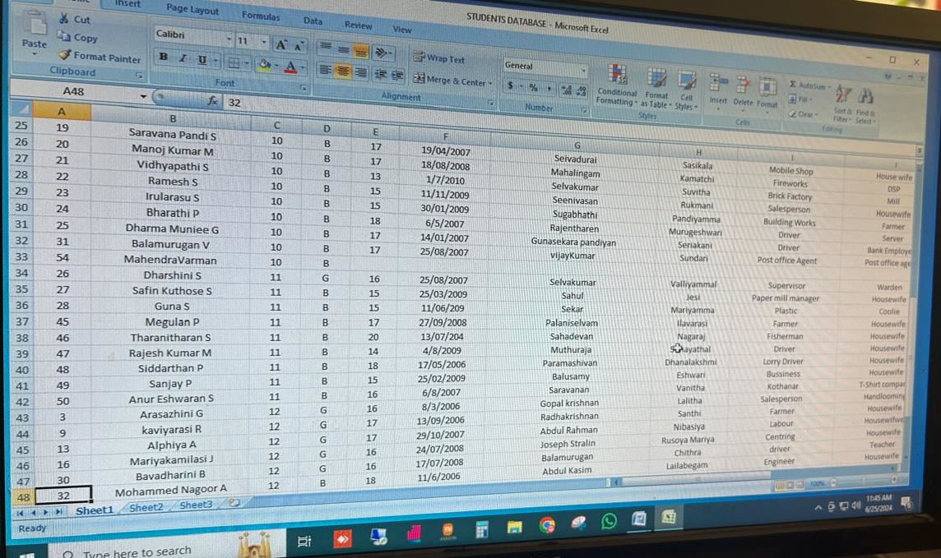

**4.4 DAY 4**

On Day 4 of my internship at Indian Association for Blind, Madurai, I entered the collected data onto Google Sheets. This process involved information about students vision percentage and family backgrounds into structured spreadsheets.

**4.5 DAY 5**

On Day 5 of my internship at Indian Association for Blind, Madurai, I collected students photos. And I continued with data entry on Google Sheets, necessary for completing scholarship forms.

**4.6 DAY 6**

On Day 6 of my internship at Indian Association for Blind, Madurai, I collected the Unique ID number from the students file and entered these details into the spreadsheet. And also put that photos in standard wise into the press cover.

**4.7 DAY 7**

On Day 7 of my internship at Indian Association for Blind, Madurai, I focused on updating Facebook events through Google Sheets. We analyse these details from the IAB Facebook account and put that details into the Google sheets.

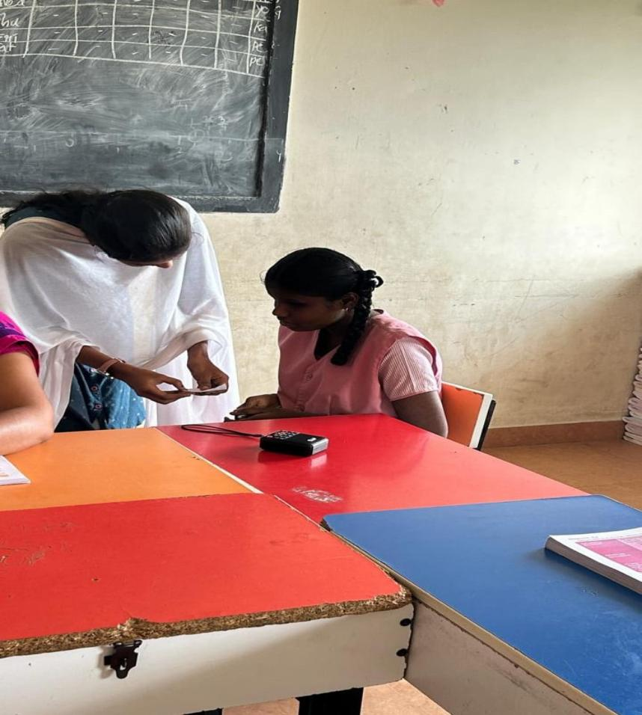

Additionally, as a gesture of appreciation on the final day of my internship, I distributed pens, pencils, and chocolates to the students. To express my thanks for their cooperation and support throughout my time at the organization.

**CONCLUSION**

This incredible nine day internship at Indian Association for the Blind has been a transformation experience, providing me with valuable insights into the life of Visually challenged peoples. I have gained practical knowledge and skills that will be invaluable in my future actions. It provided hands-on experience in administrative processes such as data organization and database management using software tools in Digi world. It will be very useful to develop my skills and support for my future growth.

**REFERENCES**

**<https://theiab.org/>**

**<https://workspace.google.com/products/sheets/>**

**<https://mrcas.edu.in/>**